BOOK WORLD PRAGUE 2009 –

ORDER OF STAND CONSTRUCTION



Application Deadline: January 15, 2009

On line registration on www.bookworld.cz/registration!

Consultations for individual requirements (and/or module alternations) provided by mac Praha, Ltd. (Komunardů 28, 170 00 Prague 7, Czech Republic, www.macpraha.cz)
Contact: Ing. Aleš Zmeškal, tel.: +420 220 800 140, fax: +420 220 876 872,
e-mail: info@macpraha.cz, ales@macpraha.cz

EXHIBITOR (Address for invoicing)

Company Name
Street |  | P. O. Box
City |  | Postal Code
Country |  | VAT Number

Contact Person
Telephone |  | Mobile
E-Mail |  | Fax

ORDER OF STAND CONSTRUCTION
Module: ……
Ordered Exhibition Space: .............. m² Dimensions (l x d): ..............m x ..............m

PRICE LIST
Module A: 690 CZK / m²
Module B: 880 CZK / m²
Module C: 950 CZK / m²
Module D: 5,175 CZK / 4 m²

Prices of all modules (except module D) do not include electrical connection.
Stands may be customized according to individual requirements.

 Electricity - up to 2,2 kW: 4,035 CZK
 Electricity - up to 4,4 kW: 6,022 CZK
 Electricity - up to 6,6 kW: 8,151 CZK
 Electricity - up to 10,5 kW: 10,997 CZK

A triple socket and electrical installation included in the price.
A list of electric appliances and their capacities can be found in the Exhibitor’s Manual that will be sent to you.

 We order 24-hours electrical supply for 500 CZK / 4 days (for refrigerator).

STAND PRINTING

In the space provided below, please write exactly what is to be printed on the overhang of your stand.
Up to 25 letters are included in stand price (Helvetica font unless otherwise indicated).

FURNITURE AND EQUIPMENT
Item | Size | CZK / Piece | Pieces
OCTANORM WHITE
counter | 50 x 100 | 330,-
counter with a shelf | 50 x 100 | 390,-
counter | 100 x 100 | 330,-
counter with a shelf | 100 x 100 | 380,-
counter | 50 x 50 | 250,-
glass counter (upper part) | 50 x 100 | 650,-
glass counter (upper part) | 100 x 100 | 830,-
glass case | 50 x 100 | 900,-
glass case | 100 x 100 | 1,250,-
glass case | 50 x 50 | 750,-
lockable staff area | 100 x 100 (walls + folding door) | 600,-
lockable staff area | each add. 1m² | 200,-
lockable folding door |  | 420,-
AL grid panel (ceiling) | 100 x 100 | 120,-
AL grid panel (ceiling) | 100 x 50 | 80,-
book shelf | 1m | 80,-
wall shelf (width 30 cm) | 1m | 80,-
shelf rack - 3 shelves | 50 x 100 | 350,-
shelf rack - 4 shelves | 50 x 100 | 390,-
wall - glass | 1m | 450,-
FURNITURE
square table | 80 x 80 | 190,-
round table | diameter 70 | 190,-
chair - upholstered |  | 120,-
chair - leather, chromium |  | 160,-
bar stool |  | 180,-
locker |  | 480,-
ELECTRO
kitchen sink with water heater |  | 1,250,-
refrigerator | 100 l | 1,000,-
electric cooker with a kettle |  | 160,-
coffee machine |  | 160,-
triple socket - extra |  | 70,-
extension cord |  | 70,-
spot light - extra |  | 140,-
OTHER EQUIPMENT
dish set - small |  | 260,-
dish set - large |  | 600,-
suspension prospectus - holder |  | 190,-
coat hooks |  | 80,-
trash basket |  | 20,-
carpet, rips - grey | 1m² | 110,-
GRAPHIC
company logo - symbol |  | 1,000 – 1,500,-
colour sheetings | 1m² | 330,-

STAND MODULES (Octanorm - white)

Should you desire for your stand equipment or arrangement different from that offered in our modules, please specify your conception in the area below:



We offer the corner stands for the same price too!

MODULE A
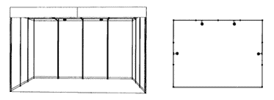

Includes: peripheral walls, front overhang, company name, stand number, lighting (1 spot light for each 3 m²), trash basket, open ceiling grid 1 x 1 m.
Not includes: electrical connection.

MODULE B
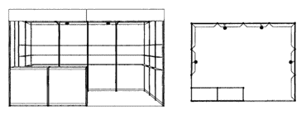

Includes: peripheral walls, front overhang, company name, stand number, lighting (1 spot light for each 3 m²), carpet, 3 shelves for each peripheral wall (excluding walls with sales counter), sales counter (100 x 50 x 100 cm) with a shelf, trash basket, open ceiling grid 1 x 1 m.
Not includes: electrical connection.

MODULE C

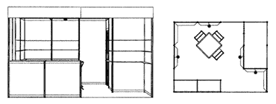

Includes: peripheral walls, front overhang, company name, stand number, lighting (1 spot light for each 3 m²), carpet, 3 shelves for each peripheral wall (excluding lockable staff area and walls with sales counter), sales counter (100 x 50 x 100 cm) with a shelf, trash basket, 1 table (square or round), 3 chairs (upholstered or folding), coat hooks or coat stand, lockable staff area - available only for stands of 12 m² and more, size of lockable staff area according to stand size, open ceiling grid 1 x 1 m.
Not includes: electrical connection.

MODULE D (4 m²)

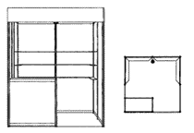

Includes: peripheral walls, front overhang, company name, stand number, 2 spot lights, carpet, sales counter (100 x 50 x 100 cm) with a shelf, 12 book shelves, trash basket, open ceiling grid 1 x 1m.

BOOKSHELF NORMAL SHELF
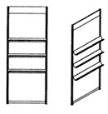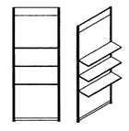

Note: Stand bookshelves may be substituted for normal shelves. If so desired, please inform us.

Invoice for services connected with stand construction will be provided by mac Praha, Ltd.
VAT 19% is not included!
When ordering stand construction services from mac Praha, Ltd., this form is an integral part of the Book World Registration.

Mailing Date:

Exhibitor’s Stamp & Signature:

